

**COMPUTER COMMUNICATIONS**

**(18CSS202J)**

**LABORATORY MANUAL**



offered by

**DEPARTMENT OF**

**ELECTRONICS AND COMMUNICATION ENGINEERING**

**FACULTY OF ENGINEERING AND TECHNOLOGY**

**SRM INSTITUTE OF SCIENCE AND TECHNOLOGY**

**Ramapuram, Chennai 600089**

**Academic year: 2021 – 2022**

**Semester: Even**

**SRM Institute of Science and Technology, Ramapuram Campus**

**Faculty of Engineering & Technology**

**Department of ECE**

**18CSS202J COMPUTER COMMUNICATIONS LABORATORY**

**2021-2022 (Even Semester)**

**Department: CSE**

**Year/Semester: II/IV**

**Name of the Student:**

**Register Number:**

**Date of Submission:**

**Staff Name :**

**Signature :**

**18CSS202J COMPUTER COMMUNICATION LABORATORY**

**List of Experiments**

| **S.No** | **Date of Experiment** | **Name of the Experiment** | **Marks** | **Faculty signature** |
| --- | --- | --- | --- | --- |
| 1. |  | STUDY OF NETWORK COMPONENTS |  |  |
| 2. |  | IP CONFIGURATION |  |  |
| 3. |  | SUBNETTING |  |  |
| 4. |  | LAN CONFIGURATION USING STRAIGHT THROUGH AND CROSS OVER CABLES |  |  |
| 5. |  | ROUTER CONFIGURATION- CREATING PASSWORDS, CONFIGURING INTERFACES |  |  |
| 6. |  | BASIC SWITCH CONFIGURATION: VLAN |  |  |
| 7. |  | CONFIGURING ROUTERS IN STATIC MODE USING PACKET TRACER |  |  |
| 8. |  | ROUTING INFORMATION PROTOCOL USING PACKET TRACER(DEFAULT ROUTING) |  |  |
| 9. |  | ROUTING INFORMATION PROTOCOL VERSION 1 |  |  |
| 10. |  | ROUTING INFORMATION PROTOCOL VERSION 2 |  |  |
| 11. |  | ENHANCED INTERIOR GATEWAY ROUTING PROTOCOL |  |  |
| 12. |  | SINGLE AREA OSPF LINK COSTS AND INTERFACES |  |  |
| 13. |  | MULTI AREA OPEN SHORTEST PATH FIRST ROUTING PROTOCOL |  |  |
| 14. |  | BORDER GATEWAY ROUTING PROTOCOL |  |  |

**EXPERIMENT-1**

**STUDY OF NETWORK COMPONENTS**

**Aim: To** study the following network devices in detail

* + PC
  + Server
  + Repeater
  + Hub
  + Switch
  + Bridge
  + Router
  + Gate Way
  + Transmission medium

1. Node: In a communications network, a network node is a connection point that can receive, create, store or send data along distributed network routes.

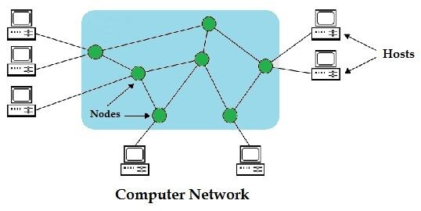

1. Repeater: Functioning at Physical Layer.

A repeater is an electronic device that receives a signal and retransmits it at a higher level and/or higher power, or onto the other side of an obstruction, so that the signal can cover longer distances.

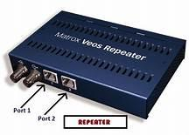 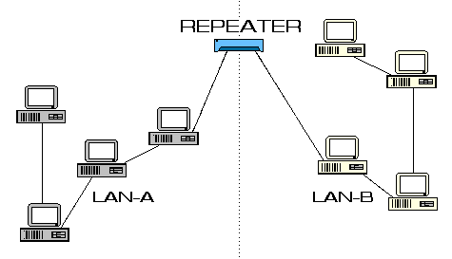

## Hub: An Ethernet hub, active hub, network hub, repeater hub

## Hub or concentrator is a device for connecting multiple twisted pair or fiber optic

## Ethernet devices together and making them act as a single network segment. Hubs

## work at the physical layer (layer 1) of the OSI model. The device is a form of

## multiport repeater. Repeater hubs also participate in collision detection, forwarding

## a jam signal to all ports if it detects a collision.

## https://tse3.mm.bing.net/th?id=OIP.AiUNvVZuKpPdAaNCfnZrUQHaDs&pid=15.1&P=0&w=301&h=151 https://tse2.mm.bing.net/th?id=OIP.K4HUMKEBZ_wYopHIdD00ogHaFj&pid=15.1&P=0&w=227&h=171

1. Switch: A network switch is a computer networking device that connects network segments. The term commonly refers to a network bridge that processes and routes data at the data link layer (layer 2) of the OSI model. Switches that additionally process data at the network layer (layer 3 and above) are often referred to as Layer 3 switches or multilayer switches.

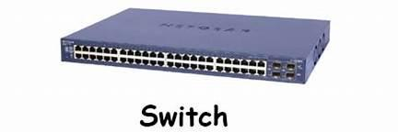 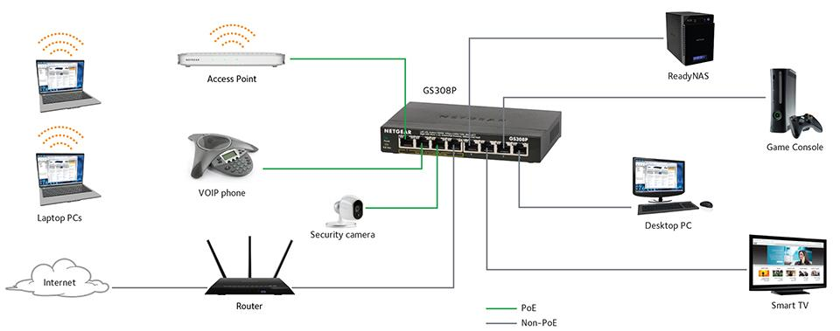 https://www.netgear.com/images/Products/Switches/UnmanagedSwitches/SOHOEthernetSwitchSeries/header-soho-switches-gs308p-connectivity-diagram-large.jpg https://www.netgear.com/images/Products/Switches/UnmanagedSwitches/SOHOEthernetSwitchSeries/header-soho-switches-gs308p-connectivity-diagram-large.jpg

5.Bridge: A network bridge connects multiple network segments at the data link layer (Layer 2) of the OSI model. In Ethernet networks, the term *bridge* formally means a device that behaves according to the IEEE 802.1D standard. A bridge and switch are very much alike; a switch being a bridge with numerous ports. *Switch* or *Layer 2 switch* is often used interchangeably with *bridge*. Bridges can analyze incoming data packets to determine if the bridge is able to send the given packet to another segment of the network.

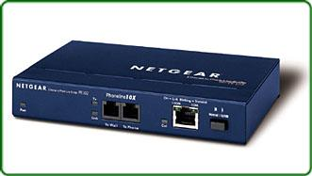https://tse1.mm.bing.net/th?id=OIP.Pv-rSDecZQDgqZJ4Ma-bYwHaHa&pid=15.1&P=0&w=300&h=300

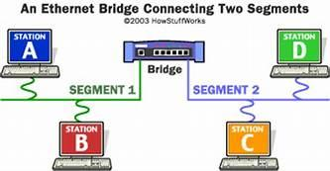

6.Router: A router is an electronic device that interconnects two or more computer networks, and selectively interchanges packets of data between them. Each data packet contains address information that a router can use to determine if the source and destination are on the same network, or if the data packet must be transferred from one network to another. Where multiple routers are used in a large collection of interconnected networks, the routers exchange information about target system addresses, so that each router can build up a table showing the preferred paths between any two systems on the interconnected networks.

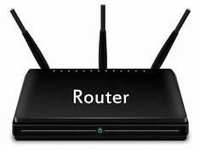

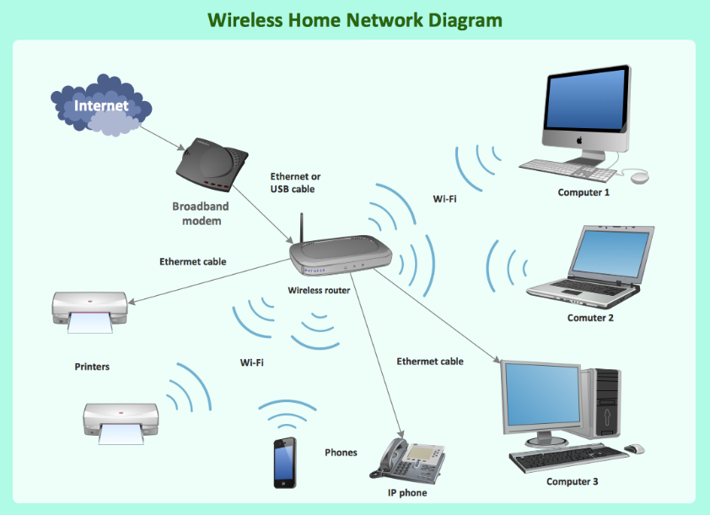

7. Gate Way:In a communications network, a network node equipped for interfacing

with another network that uses different protocols. A gateway may contain devices

such as protocol translators, impedance matching devices, rate converters, fault isolators,

signal translators as necessary to provide system interoperability. It also requires the

establishment of mutually acceptable administrative procedures between both networks . A protocol translation/mapping gateway interconnects networks with different network

protocol technologies by performing the required protocol conversions.

.

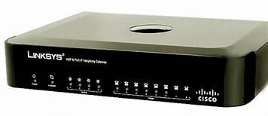

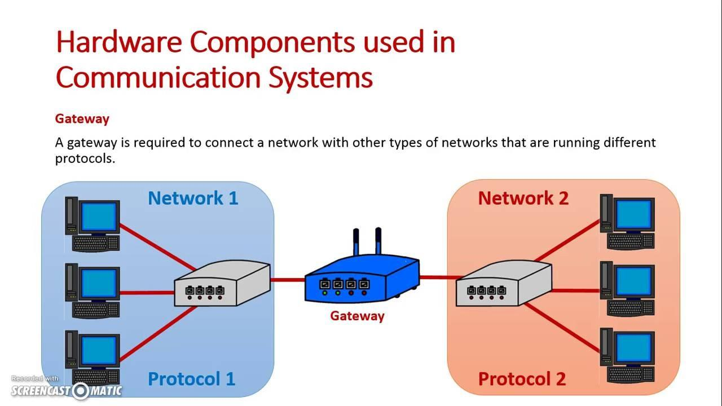

8.Server:A server is a type of [computer](https://www.webopedia.com/TERM/C/computer.html) or [device](https://www.webopedia.com/TERM/D/device.html) on a [network](https://www.webopedia.com/TERM/N/network.html) that manages network [resources](https://www.webopedia.com/TERM/R/resource.html). Servers are often [dedicated](https://www.webopedia.com/TERM/D/dedicated_server.html), meaning that they perform no other tasks besides their server tasks. Onmultiprocessing [operating systems](https://www.webopedia.com/TERM/O/operating_system.html), however, a single computer can [execute](https://www.webopedia.com/TERM/E/execute.html) several [programs](https://www.webopedia.com/TERM/P/program.html) at once. A server in this case could refer to the program that is managing resources rather than the entire computer.

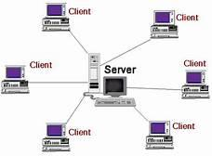

9. Transmission media: The medium through which the signals travel from one device to another. These are classified as guided and unguided. Guided media are those that provide a conduit from one device to another. Eg Twisted pair, coaxial cable etc. Unguided media transport signals without using physical cables. Eg. Air.

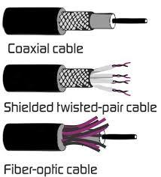 

**Result:** Thus the network components are studied in detail.

**EXPERIMENT-2**

**IP CONFIGURATION**

**Aim: To configure the IP address for the hosts in a star topology**

**Software/Components required: Cisco** Packet Tracer 7.1/End devices, Generic Hub, connectors.

**Procedure**

**Steps for building topology:**

Step 1: Start Packet Tracer

Step 2: Choosing Devices and Connections

Step 3: Building the Topology – Adding Hosts

Click on the end devices.

Click on the generic host.

Move the cursor into topology area.

Single click in the topology area and it copies the device.

Step 4: Building the Topology – Connecting the Hosts to Hub

Select a generic Hub, by clicking once on Hub and once on a generic hub

Step 5: Connect PCs to host by first choosing Connections

Click once on the Copper Straight-through cable

Click once on PC0

Choose Fastethernet

Drag the cursor to Hub0

Click once on Hub0.

Step 6: Configuring IP Addresses and Subnet Masks on the Hosts

To start communication between the hosts IP Addresses and subnet masks had to be

configured on the devices. Click once on PC0. Choose the Config tab and click on

FastEthernet0. Type the IP address in its field. Click on the subnet mask.it will be

generated automatically.

Step 7: To confirm Data transfer between the devices

Click on the node. Select desktop option and then command prompt. Once the window

pops up, ping the IP address of the device to which node0 is connected. Ping statistics

will be displayed. (or)

Verifying Connectivity in Real time Mode

Click on the Real time mode.

Select the Add Simple PDU tool used to ping devices.

Click once on PC0, then once on PC3.

The PDU Last Status should show as Successful.

Verifying Connectivity in Simulation Mode

Click on the Simulation mode.

Disable all filters and select only ICMP.

Select the Add Simple PDU tool used to ping devices

Click once on PC0, then once on PC3.Continue clicking Capture/Forward button

until the ICMP ping is completed. The ICMP messages move between the hosts, hub

and switch. The PDU Last Status should show as successful.

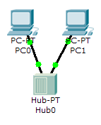

**Simulated Output:**

**Result:** Thus the hosts in a Star topology are configured and simulated using Packet Tracer 7.1 simulation Tool.

**EXPERIMENT 3**

**SUBNETTING**

**Aim:** To subnet a given network and simulate using Cisco packet tracer simulation tool

**Software used**: Cisco Packet Tracer

**Network components**: PCs-6, Routers 2, Connectors, switches 2

**Scenario:** To subnet a network with IP address: **192.168.1.0/27** and to find the subnet network

address, broadcast address and host address of the subnets.

(i) Total no of subnets in this IP address = 2^n = 2^3=**8 Networks**

(ii) No of hosts in each sub network: 256 (0 to 255) = 256/8=**32 Hosts**

**iii) The subnet mask is :** 255.255.255.224

255 255 255 224

11111111 11111111 11111111 11100000

iv) The number of subnets is 8 .The first address of the subnet is the network address, last

address is the broadcast address and the remaining 30 addresses are allocated to the hosts.

| NETWORK | IP | NETWORK ID | HOST ID | BROADCAST ID |
| --- | --- | --- | --- | --- |
| NETWORK 1 | 192.168.1.0 | 192.168.1.0 | 192.168.1.1 | 192.168.1.31 |
| 192.168.1.31 | 192.168.1.30 |
| NETWORK 2 | 192.168.1.32 | 192.168.1.32 | 192.168.1.33 | 192.168.1.63 |
| 192.168.1.63 | 192.168.1.62 |
| NETWORK 3 | 192.168.1.64 | 192.168.1.64 | 192.168.1.65 | 192.168.1.95 |
| 192.168.1.95 | 192.168.1.94 |
| NETWORK 4 | 192.168.1.96 | 192.168.1.96 | 192.168.1.97 | 192.168.1.127 |
| 192.168.1.127 | 192.168.1.126 |
| NETWORK 5 | 192.168.1.128 | 192.168.1.128 | 192.168.1.129 | 192.168.1.159 |
| 192.168.1.159 | 192.168.1.158 |
| NETWORK 6 | 192.168.1.160 | 192.168.1.160 | 192.168.1.161 | 192.168.1.191 |
| 192.168.1.191 | 192.168.1.190 |
| NETWORK 7 | 192.168.1.192 | 192.168.1.192 | 192.168.1.193 | 192.168.1.223 |
| 192.168.1.223 | 192.168.1.222 |
| NETWORK 8 | 192.168.1.224 | 192.168.1.224 | 192.168.1.225 | 192.168.1.255 |
| 192.168.1.255 | 192.168.1.254 |

**Procedure:**

Step 1**:** Select the generic hosts, switches and routers

Step 2: Connect the host, switches and routers using copper cross over and router to router

using serial DCE

Step 3: Identify the networks and label as 192.168.1.0, 192.168.1.32 and 192.168.1.64

Step 4: Configure the generic hosts with the following IP address and gateway address

| Host | IP address | Gateway | Network |
| --- | --- | --- | --- |
| PC0 | 192.168.1.1 | 192.168.1.4 | 192.168.1.0 |
| PC1 | 192.168.1.2 | 192.168.1.4 | 192.168.1.0 |
| PC2 | 192.168.1.3 | 192.168.1.4 | 192.168.1.0 |
| PC3 | 192.168.1.65 | 192.168.1.68 | 192.168.1.64 |
| PC4 | 192.168.1.66 | 192.168.1.68 | 192.168.1.64 |
| PC5 | 192.168.1.67 | 192.168.1.68 | 192.168.1.64 |

Step 5: Configure the router 0 by clicking on the config. The router is connected to 2

networks. For each connection, separate IP addresses are assigned. For connections to

network 1 and 2 the IP address for router 0 are 192.168.1.4 and 192.168.1.33

respectively. Similarly for router 1, to connect to network 2 ad 3, the IP addresses are

192.168.1.34 and 192.168.1.68 Choose the subnet mask as 255.255.255.224.Select the

fast Ethernet for connecting host and router and serial interface for connecting the

routers. click on the port status to turn on the router.

Step 6: To configure router in static mode click on the router 0, select the static mode. Type the

address of the network to which the packets to be sent (192.168.1.64) and the address

of the next router(192.168.1.34). Click ok. Similarly click on the router 1, select the

static mode. Type the address of the network to which the packets has to be sent

(192.168.1.0) and the address of the next router (192.168.1.33).

Step 7: To confirm Data transfer between the devices

Click on the node. Select desktop option and then command prompt. Once the window

pops up, ping the IP address of the device to which node0 is connected. Ping statistics

will be displayed. Also simulate in simulation and real mode.

**Simulation Output:**

**Result:** Thus the subnetting of the given network is carried out and simulated using packet

tracer simulation tool.

**EXPERIMENT 4**

**LAN CONFIGURATION USING STRAIGHT THROUGH AND CROSS OVER CABLES**

**Aim:** To simulate the segments of a LAN which is in bus and tree topology and hence to connect the segments using switch, crossover and straight through cables in Cisco packet tracer**.**

**Software/Components required:** Packet Tracer/End devices, switches, cross over and straight through cables**.**

**Steps for building bus and tree topology:**

Step 1: Choosing Devices and Connections

Step 2: Building the tree topology and bus topolgy– Adding Hosts

Single click on the End Devices.

Single click on the Generic host.

Move the cursor into topology area.

Single click in the topology area and it copies the device.

Step 3: Building the Topology – Connecting the Hosts to switches

Select a switch, by clicking once on switch and once on a generic switch

Add the switch by moving the plus sign “+”

Step 4: Connect PCs to switch by choosing straight through cables

Click once on the straight through cable

Click once on PC

Choose Fast Ethernet

Drag the cursor to Switch0

Click once on Switch0

Notice the green link lights on PC Ethernet NIC and amber light Switch port.The switch port is temporarily not forwarding frames, while it goes through the stages for the Spanning Tree Protocol (STP) process. After about 30 seconds the amber light will change to green indicating that the port has entered the forwarding stage. Frames can now forward out of the switch port.

Step 5: Configuring IP Addresses and Subnet Masks on the Hosts

To start communication between the hosts IP Addresses and Subnet Masks had to be

configured on the devices. Click once on PC0. Choose the config tab and click on

FastEthernet0. Type the IP address in its field. Click on the subnet mask.it will be

generated automatically.

Step 6: To create a tree topology connect each of the PC to the corresponding switch and interconnect the switches using cross over cables

Step 7: To create a bus topology connect each of the PC to the switch using straight through

cable and connect the switches using cross over cables

Step 7: To confirm Data transfer between the devices

Click on the node. Select desktop option and then command prompt. Once the window

pops up, ping the IP address of the device to which node0 is connected. Ping statistics

will be displayed.

Step 8: Connect the two segments of the LAN using a switch.

Step 9: Simulate the tree and bus topologies which are segments of the same LAN in

Simulation mode and Real time mode

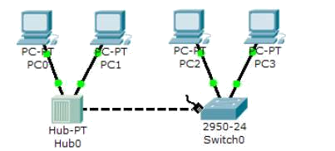

**Simulation Output:**

**Result:** Thus the LAN configuration using crossover and straight through cables is

simulated in Cisco packet tracer.

**EXPERIMENT 5**

**ROUTER CONFIGURATION (CREATING PASSWORDS, CONFIGURING INTERFACES)**

**Aim:** To simulate Routing Information Protocol using packet tracer simulation tool

.

**Software used**: Cisco Packet Tracer

**Network components**: PCs-2, Routers 2, Connectors

**Procedure**

Step 1**:** Select the generic hosts, switches and routers

Step 2: Connect the host, switches and routers using copper cross over and router to router

using serial DCE

Step 3: Identify the networks and label as 20.20.20.0,50.50.50.0 and 30.30.30.0

Step 4: Configure the generic hosts PC0 with the IP address 20.20.20.2, gateway address

20.20.20.1 and host 2 with IP address 30.30.30.2 and gate way address 30.30.30.1

Step 5: Configuration of the router 0 and router 1 are done by CLI commands. The router0

is connected to 2 networks. For each connection, separate IP addresses are assigned.

For connections to network 1 and 2 the IP address for router 0 are 20.20.20.0 and.

50.50.50.0 respectively. Similarly for router 1, to connect to network 2 and 3, the IP

addresses are 50.50.50.0 and 30.30.30.0. Choose the subnet mask as

255.255.255.0.Router 0 is configured by clicking on the CLI. Following are the

commands for changing the router name ,configuring the interfaces and creating

password.

router>en

router #configure terminal

*Enter configuration commands, one per line. End with CNTL/Z.*

Router # hostname Router1

Router1(config)#interface fa0/0

Router1(config-if)#ip address 20.20.20.1 255.255.255.0

Router1(config-if)#no shut

Router1(config-if)#exit

Router1(config)#interface se2/0

Router1(config-if)#ip address 50.50.50.1 255.255.255.0

Router1(config-if)#clock rate 64000

Router1(config-if)#no shut

Router1*(config-if)#*

*%LINK-5-CHANGED: Interface Serial2/0, changed state to up*

Router1*(config-if)#*

*%LINEPROTO-5-UPDOWN: Line protocol on Interface Serial2/0, changed state to up*

Router1(config-if)#exit

Router1(config)#router rip

Router1(config-router)#network 20.20.20.0

Router1(config-router)#network 50.50.50.0

Router1(config-router)#exit

Router1(config)#line console 0

Router1(config-line)#password 12345

Router1(config-line)#login

Router1(config-line)#exit

Router1(config)#

Router1(config)#

Router1(config)#exit

*Router1#*

*%SYS-5-CONFIG_I: Configured from console by console*

Router1#exit

*Router1 con0 is now available*

*Press RETURN to get started.*

*User Access Verification*

*Password:*

Step 6: The second router is also configured using the above commands.

Step 7: To confirm data transfer between the devices

Click on the node. Select desktop option and then command prompt. Once the window

pops up, ping the IP address of the device to which node0 is connected. Ping statistics

will be displayed. Also simulate in simulation and real mode.

**Simulation Output:**

**Result:** Thus the configuration of router using CLI commands is simulated using packet tracer

**EXPERIMENT 6**

**BASIC SWITCH CONFIGURATION: VLAN**

**Aim: To configure the VLAN and simulate in the Cisco Packet Tracer**

**Software/Components required: Cisco** Packet Tracer 7.1/ End devices PCs-8, Switch 2950-24, connectors.

**Procedure**

**Steps for building topology:**

Step 1: Start Packet Tracer

Step 2: Choosing Devices and Connections

Step 3: Building the Topology – Adding Hosts

Click on the end devices.

Click on the generic host.

Move the cursor into topology area.

Single click in the topology area and it copies the device.

Step 4: Select the switch 2650-24, by clicking once on switch and once on the switch 2650-24

Add the switch by moving the plus sign “+”

Connect PCs to switch by first choosing Connections

Click once on the Copper Straight-through cable

Click once on PC0

Choose Fastethernet

Drag the cursor to Switch0

Click once on Switch0

Notice the green link lights on PC Ethernet NIC and amber light switch port. The switch port is temporarily not forwarding frames, while it goes through the stages for the Spanning Tree Protocol (STP) process. After about 30 seconds the amber light will change to green indicating that the port has entered the forwarding stage. Frames can now forward out the switch port.

Step 5: Configuring IP Addresses and Subnet Masks on the Hosts

To start communication between the hosts IP Addresses and subnet masks had to be

configured on the devices. Click once on PC0. Choose the Config tab and click on

FastEthernet0. Type the IP address 192.168.1.1 in its field. Click on the subnet mask.it

will be generated automatically(255.255.255.0) Similarly configure the other PCs.

Step 6: To confirm Data transfer between the devices

Click on the node. Select desktop option and then command prompt. Once the window

pops up, ping the IP address of the device to which node0 is connected. Ping statistics

will be displayed. (or)

Verifying Connectivity in Real time Mode

Click on the Real time mode.

Select the Add Simple PDU tool used to ping devices.

Click once on PC0, then once on PC3.

The PDU Last Status should show as Successful.

Verifying Connectivity in Simulation Mode

Click on the Simulation mode.

Disable all filters and select only ICMP.

Select the Add Simple PDU tool used to ping devices

Click once on PC0, then once on PC3.Continue clicking Capture/Forward button

until the ICMP ping is completed. The ICMP messages move between the hosts, hub

and switch. The PDU Last Status should show as successful.

Step 7: Configuring virtual LAN.VLAN technology is to divide a LAN into logical instead

of physical LANS. Each VLAN is a work group in an organization. The membership

is defined by software. The members of a VLAN can send messages to other

members of same group with assurance that members of other VLAN will not

receive this message. To configure VLAN click on the switch. Click on the interface

fa0/1. Give the desired VLAN number in the VLAN field, Click onto VLAN

database. Enter the VLAN number and VLAN name and click add. To confirm Data

transfer between the devices Click on the node. Select desktop option and then

command prompt. Once the window pops up, ping the IP address of the device to

which node0 is connected. Ping statistics will be displayed.

**Simulation output:**

**Result:** Thus the VLAN is configured and simulated using Packet Tracer simulation tool.

**EXPERIMENT 7**

**CONFIGURING ROUTERS IN STATIC MODE USING PACKET TRACER**

**Aim:** To configure router in static mode using packet tracer simulation tool

.

**Software used**: Cisco Packet Tracer

**Network components**: PCs-2, Routers 2, Connectors

**Procedure**

Step 1**:** Select the generic hosts and routers

Step 2: Connect the host and routers using copper cross over and router to router using serial

DCE

Step 3: Identify the networks and label as 10.10.1.0, 10.10.2.0 and 10.10.3.0

Step 4: Configure the generic hosts PC0 with the IP address 10.10.1.1, gateway address

10.10.1.2 and host 2 with IP address 10.10.3.1and gate way address 10.10.3.2

Step 5: Configure the router 0 by clicking on the config. The router is connected to 2

networks. For each connection, separate IP addresses are assigned. For connections to

network 1 and 2 the IP address for router 0 are 10.10.1.2 and 10.10.2.1 respectively.

Similarly for router 1, to connect to network 2 ad 3, the IP addresses are 10.10.2.2 and

10.10.3.2. Choose the subnet mask as 255.255.255.0.Select the fastethernet for

connecting host and router and serial interface for connecting the routers click on the

port status to turn on the router.

Step 6: To configure router in static mode click on the router 0, select the static mode. Type the

address of the network to which the packets to be sent (10.10.3.0) and the address of .

the next router(10.10.2.2). Click ok. Similarly click on the router 1,select the static

mode. Type the address of the network to which the packets to be sent (10.10.1.0) and

the address of the next router(10.10.2.1).

Step 7: To confirm Data transfer between the devices

Click on the node. Select desktop option and then command prompt. Once the window

pops up, ping the IP address of the device to which node0 is connected. Ping statistics

will be displayed. Also simulate in simulation and real mode.

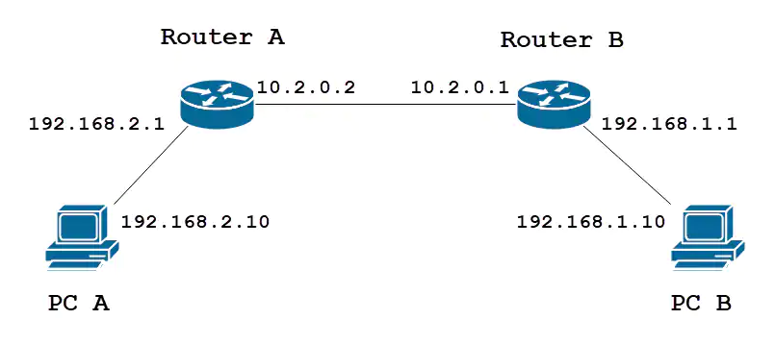Image result for static configuration of routerImage result for static configuration of router

C:\Users\Admin\Desktop\kmgmt-2334-Static-Routing-RV160-RV260-image-1.webp

**Simulation Output:**

**Result:** Thus the router is configured in static mode using packet tracer simulation tool.

**EXPERIMENT 8**

**ROUTING INFORMATION PROTOCOL USING PACKET TRACER (DEFAULT ROUTING)**

**Aim:** To simulate Routing Information Protocol (Default) using packet tracer simulation tool

.

**Software used**: Cisco Packet Tracer

**Network components**: PCs-2, Routers 2, Connectors

**Procedure**

Step 1**:** Select the generic hosts, switches and routers

Step 2: Connect the host, switches and routers using copper cross over and router to router

using serial DCE

Step 3: Identify the networks and label as 10.10.1.0, 10.10.2.0 and 10.10.3.0

Step 4: Configure the generic hosts PC0 with the IP address 10.10.1.1, gateway address

10.10.1.2 and host 2 with IP address 10.10.3.1and gate way address 10.10.3.2

Step 5: Configure the router 0 by clicking on the config. The router is connected to 2

networks. For each connection, separate IP addresses are assigned. For connections to

network 1 and 2 the IP address for router 0 are 10.10.1.2 and 10.10.2.1 respectively.

Similarly for router 1, to connect to network 2 ad 3, the IP addresses are 10.10.2.2 and

10.10.3.2. Choose the subnet mask as 255.255.255.0.Select the fastethernet for

connecting host and router and serial interface for connecting the routers click on the

port status to turn on the router.

Step 6: To configure Routing Information Protocol , click on the router 0,select RIP. Type the

address of the networks which the router knows (10.10.2.0). Click add. Again type the . address which router knows(10.10.1.0). Click add. Go to settings and save the

configuration in NVRAM. Similarly click on the router 1, add the addresses 10.10.2.0

and 10.10.3.0

Step 7: To confirm Data transfer between the devices

Click on the node. Select desktop option and then command prompt. Once the window

pops up, ping the IP address of the device to which node0 is connected. Ping statistics

will be displayed. Also simulate in simulation and real mode.

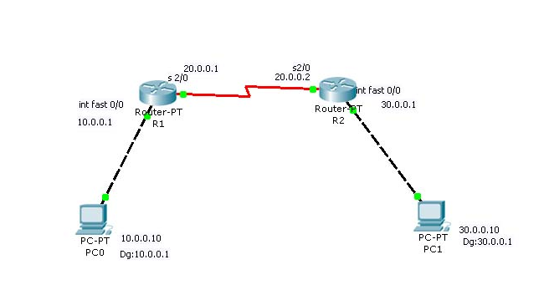

**Simulation Output:**

**Result:** Thus the Routing Information Protocol (Default Routing) is simulated using packet tracer simulation tool.

**EXPERIMENT 9**

**ROUTING INFORMATION PROTOCOL (V1) USING PACKET TRACER**

**Aim:** To simulate Routing Information Protocol (V1) using packet tracer simulation tool

.

**Software used**: Cisco Packet Tracer

**Network components**: PCs 4, Routers 2, Connectors, Switches 2

**Procedure**

Step 1**:** Select the generic hosts, switches and routers

Step 2: Connect the host, switches and routers using copper cross over and router to router

using serial DCE

Step 3: Identify the networks and label as 100.100.100.0, 150.150.150.0 and 200.200.200.3

Step 4: Configure the generic hosts PC0 and PC1 with the IP address 100.100.100.1 and

100.100.100.2 with gateway address 100.100.100.3 respectively. Configure the generic

hosts PC2 and PC3 with the IP address 200.200.200.1and 200.200.200.2 with gateway

address 200.200.200.3 respectively.

Step 5: Configure the router 0 by clicking on the config. The router is connected to 2

networks. For each connection, separate IP addresses are assigned. For connections to

network 1 and 2 the IP address for router 0 are 100.100.100.3 and.

150.150.150.1 respectively. Similarly for router 1, to connect to network 2 ad 3, the IP

addresses are 150.150.150.2 and 200.200.200.3. Choose the subnet mask as

255.255.255.0.Select fast Ethernet interface for connecting host and router and serial

interface for connecting the routers click on the port status to turn on the router .

Step 6: To configure Routing Information Protocol, click on the router 0, select RIP. Type the

address of the networks which the router is connected (100.100.100.0). Click on add.

Again type the address which router knows (150.150.150.0). Click on add. Go to

settings and save the configuration in NVRAM. Similarly click on the router 1, add the

addresses 150.150.150.0 and 200.200.200.0

Step 7: To confirm Data transfer between the devices

Click on the node. Select desktop option and then command prompt. Once the window

pops up, ping the IP address of the device to which node0 is connected. Ping statistics

will be displayed. Also simulate in simulation and real mode.



**Simulation Output:**

**Result:** Thus the Routing Information Protocol (Version 1) is simulated using packet tracer

simulation tool.

**EXPERIMENT 10**

**ROUTING INFORMATION PROTOCOL(V2)USING PACKET TRACER**

**Aim:** To simulate Routing Information Protocol (V2) using packet tracer simulation tool

.

**Software used**: Cisco Packet Tracer

**Network components**: PCs 4, Routers 2, Connectors, Switches 2

**Procedure**

Step 1**:** Select the generic hosts, switches and routers

Step 2: Connect the host, switches and routers using copper cross over and router to router

using serial DCE

Step 3: Identify the networks and label as 192.168.1.0, 192.168.1.32 and 192.168.1.64

Step 4: Configure the generic hosts with the following IP address and gateway address

| Host | IP address | Gateway | Network |
| --- | --- | --- | --- |
| PC0 | 192.168.1.1 | 192.168.1.3 | 192.168.1.0 |
| PC1 | 192.168.1.2 | 192.168.1.3 | 192.168.1.0 |
| PC2 | 192.168.1.65 | 192.168.1.67 | 192.168.1.64 |
| PC3 | 192.168.1.66 | 192.168.1.67 | 192.168.1.64 |

Step 5: Configure the router 0 by clicking on the config. The router is connected to 2

networks. For each connection, separate IP addresses are assigned. For connections to

network 1 and 2 the IP address for router 0 are 192.168.1.3 and 192.168.1.33

respectively. Similarly for router 1, to connect to network 2 ad 3, the IP addresses are

192.168.1.34 and 192.168.1.67 Choose the subnet mask as 255.255.255.224.Select the

fastethernet for connecting host and router and serial interface for connecting the

routers click on the port status to turn on the router.

Step 6: To configure Routing Information Protocol version 2, click on the router 0.Click on the

CLI . Type the following commands

#en

#config t

# router rip

# version 2

#network 192.168.1.0

#network 192.168.1.32

#exit

Similarly click on the router 2, click on the CLI .Type the following commands

#en

#config t

# router rip

# version 2

#network 192.168.1.64

#network 192.168.1.32

#exit

Step 7: To confirm Data transfer between the devices

Click on the node. Select desktop option and then command prompt. Once the window

pops up, ping the IP address of the device to which node0 is connected. Ping statistics

will be displayed. Also simulate in simulation and real mode.

**Simulation output:**

**Result:** Thus the Routing Information Protocol (Version 2) is simulated using packet tracer

simulation tool.

**EXPERIMENT-11**

**ENHANCED INTERIOR GATEWAY ROUTING PROTOCOL**

**Aim:** To simulate Enhanced Interior Gateway Routing Protocol (EIGRP) using Cisco packet

. tracer simulation tool

**Software used**: Cisco Packet Tracer

**Network components**: PCs-6, Routers 3, Connectors, switches (3)

**Procedure**

Step 1**:** Select the generic hosts, switches and routers

Step 2: Connect the host, switches and routers using copper cross over and router to router

using serial DCE

Step 3: Identify the networks and label as 192.168.1.0, 192.168.2.0,192.168.3.0,10.0.0.0

and 20.0.0.0

Step 4: Configure the generic hosts with the following IP address and gateway address

| Host | IP address | Gateway | Network |
| --- | --- | --- | --- |
| PC0 | 192.168.1.2 | 192.168.1.1 | 192.168.1.0 |
| PC1 | 192.168.1.3 | 192.168.1.1 | 192.168.1.0 |
| PC2 | 192.168.2.2 | 192.168.2.1 | 192.168.2.0 |
| PC3 | 192.168.2.3 | 192.168.2.1 | 192.168.2.0 |
| PC4 | 192.168.3.2 | 192.168.3.1 | 192.168.3.0 |
| PC5 | 192.168.3.3 | 192.168.3.1 | 192.168.3.0 |

Step 5: Configure the router 0 by clicking on the config. The router0 is connected to 2

networks. For each connection, separate IP addresses are assigned. For connections to

networks 1 and 2, the IP address for router 0 are 192.168.1.1 and 10.0.0.1 respectively.

Similarly for router 1, to connect to network 1,2 ad 3, the IP addresses are 10.0.0.2

192.168.2.1 and 20.0.0.1 and for router 2 to connect to network 2 and 3 the IP address

are 20.0.0.2 and 192.168.3.1.Choose the subnet mask as 255.255.255.0 and 255.0.0.0.

based on the IP address. Select the fast Ethernet interface for connecting host and

router and serial interface for connecting the routers click on the port status to turn on

the router

Step 6: To configure Enhanced Interior Gateway Routing Protocol(EIGRP)click on the router

0,click on the CLI. Type the following commands

#en

#config t

# router eigrp 1

#network 192.168.1.0

#network 10.0.0.0 0

#exit

Similarly click on the router 1, click on the CLI .Type the following commands

#en

#config t

# router eigrp 1

#network 192.168.2.0

#network 10.0.0.0

#network 20.0.0.0

#exit

Similarly click on the router 2, click on the CLI .Type the following commands

#en

#config t

# router eigrp 1

#network 192.168.3.0

#network 20.0.0.0

#exit

Step 7: To confirm Data transfer between the devices

Click on the node. Select desktop option and then command prompt. Once the window

pops up, ping the IP address of the device to which node0 is connected. Ping statistics

will be displayed. Also simulate in simulation and real mode.

**Simulation Output:**

**Result:** Thus the Enhanced Interior Gateway Routing Protocol (EIGRP) is simulated using

packet tracer simulation tool.

**EXPERIMENT-12**

**SINGLE AREA OSPF LINK COSTS AND INTERFACES**

**Aim:** To simulate single area Open Shortest Path First routing protocol using Cisco packet

. tracer simulation tool

**Software used**: Cisco Packet Tracer

**Network components**: PCs-2, Routers 2, Connectors

**Procedure**

Step 1**:** Select the generic hosts, switches and routers

Step 2: Connect the host, switches and routers using copper cross over and router to router

using serial DCE

Step 3: Identify the networks and label as 10.10.1.0, 10.10.2.0 and 10.10.3.0

Step 4: Configure the generic hosts PC0 with the IP address 10.10.1.1, gateway address

10.10.1.2 and host 2 with IP address 10.10.3.1and gate way address 10.10.3.2

Step 5: Configure the router 0 by clicking on the config. The router is connected to 2

networks. For each connection, separate IP addresses are assigned. For connections to

network 1 and 2 the IP address for router 0 are 10.10.1.2 and 10.10.2.1 respectively.

Similarly for router 1, to connect to network 2 ad 3, the IP addresses are 10.10.2.2 and

10.10.3.2. Choose the subnet mask as 255.255.255.0.Select the fastethernet for

connecting host and router and serial interface for connecting the routers click on the

port status to turn on the router.

OSPF has some basic rules when it comes to area assignment. OSPF must be

configured with areas. The backbone area 0, or 0.0.0.0, must be configured if more

than one area assignment is done. If OSPF is configured in one area; any area can be

chosen, although good OSPF design dictates to configure area 0.

Step 6: To configure OSPF click on the router 0,click on the CLI. Type the following

commands

#router ospf 1

#network 10.10.1.0 0.0.0.255 area 0

#network 10.10.2.0 0.255.255.255 area 0

#exit

Similarly click on the router 1, click on the CLI .Type the following

commands.

#router ospf 1

#network 10.10.3.0 0.0.0.255 area 0

#network 10.10.2.0 0.255.255.255 area 0

#exit

Step 7: To confirm Data transfer between the devices

Click on the node. Select desktop option and then command prompt. Once the window

pops up, ping the IP address of the device to which node0 is connected. Ping statistics

will be displayed. Also simulate in simulation and real mode.

**Simulation Output:**

**Result:** Thus the single area Open Shortest Path First Protocol is simulated using packet tracer

simulation tool.

**EXPERIMENT-13**

**MULTI AREA OPEN SHORTEST PATH FIRST ROUTING PROTOCOL**

**Aim:** To simulate Multi Area Open Shortest Path First routing protocol using Cisco packet

. tracer simulation tool

**Software used**: Cisco Packet Tracer

**Network components**: PCs-6, Routers 3, Connectors, switches (3)

**Procedure**

Step 1**:** Select the generic hosts, switches and routers

Step 2: Connect the host, switches and routers using copper cross over and router to router

using serial DCE

Step 3: Identify the networks and label as 192.168.1.0, 192.168.2.0,192.168.3.0,10.0.0.0

and 20.0.0.0

Step 4: Configure the generic hosts with the following IP address and gateway address

| Host | IP address | Gateway | Network |
| --- | --- | --- | --- |
| PC0 | 192.168.1.2 | 192.168.1.1 | 192.168.1.0 |
| PC1 | 192.168.1.3 | 192.168.1.1 | 192.168.1.0 |
| PC2 | 192.168.2.2 | 192.168.2.1 | 192.168.2.0 |
| PC3 | 192.168.2.3 | 192.168.2.1 | 192.168.2.0 |
| PC4 | 192.168.3.2 | 192.168.3.1 | 192.168.3.0 |
| PC5 | 192.168.3.3 | 192.168.3.1 | 192.168.3.0 |

Step 5: Configure the router 0 by clicking on the config. The router0 is connected to 2

networks. For each connection, separate IP addresses are assigned. For connections to

networks 1 and 2, the IP address for router 0 are 192.168.1.1 and 10.0.0.1 respectively.

Similarly for router 1, to connect to network 1,2 ad 3, the IP addresses are 10.0.0.2

192.168.2.1 and 20.0.0.1 and for router 2 to connect to network 2 and 3 the IP address

are 20.0.0.2 and 192.168.3.1.Choose the subnet mask as 255.255.255.0 and 255.0.0.0.

based on the IP address. Select the fast Ethernet interface for connecting host and

router and serial interface for connecting the routers click on the port status to turn on

the router .OSPF has some basic rules when it comes to area assignment. OSPF must

be configured with areas. The backbone area 0, or 0.0.0.0, must be configured if more

than one area assignment is done. The network 192.168.2.0 is considered as backbone

area. Other areas are defined as area10 and area 20

Step 6: To configure multi area OSPF click on the router 0,click on the CLI. Type the

following commands

#en

#config t

# router ospf 1

#network 192.168.1.0 0.0.0.255 area 10

#network 10.0.0.0 0.255.255.255 area 10

#end

Similarly click on the router 1, click on the CLI .Type the following

commands.

#en

#config t

# router ospf 1

#network 192.168.2.0 0.0.0.255 area 0

#network 10.0.0.0 0.255.255.255 area 10

#network 20.0.0.0 0.255.255.255 area 20

#end

Similarly click on the router 2, click on the CLI .Type the following

commands.

#en

#config t

# router ospf 1

#network 192.168.3.0 0.0.0.255 area 20

#network 20.0.0.0 0.255.255.255 area 20

#end

Step 7: To confirm Data transfer between the devices

Click on the node. Select desktop option and then command prompt. Once the window

pops up, ping the IP address of the device to which node0 is connected. Ping statistics

will be displayed. Also simulate in simulation and real mode.

**Simulation Output:**

**Result:** Thus the Multi area Open Shortest Path First Protocol is simulated using packet tracer

simulation tool.

**EXPERIMENT-14**

**BORDER GATEWAY ROUTING PROTOCOL**

**Aim:** To simulate Border Gateway Routing protocol using Cisco packet tracer simulation

. tool

**Software used**: Cisco Packet Tracer

**Network components**: PCs-2, Routers 2, Connectors

**Procedure**

Step 1**:** Select the generic hosts, switches and routers

Step 2: Connect the host, switches and routers using copper cross over and router to router

using serial DCE

Step 3: Identify the networks and label as 192.168.1.0, 192.168.2.0 and 192.168.3.0

Step 4: Configure the generic hosts PC0 with the IP address 192.168.1.2, gateway address

192.168.1.1 and host 2 with IP address 192.168.3.2and gateway address 192.168.3.1

Step 5: Configure the router 0 by clicking on the config. The router is connected to 2

networks. For each connection, separate IP addresses are assigned. For connections to

network 1 and 2 the IP address for router 0 are 192.168.1.1 and 192.168.2.1

respectively Similarly for router 1, to connect to network 2 ad 3, the IP addresses are

192.168.2.2 and 192.168.3.1.Choose the subnet mask as 255.255.255.0.Select the on

fastethernet for connecting host and router and serial interface for connecting the

routers. Click port status to turn on the router.

Border gate way Routing Protocol is an inter domain routing protocol .Hence the

autonomous systems are defined as AS100 and AS200

Step 6: To configure BGP click on the router 0,click on the CLI. Type the following

commands

#en

#config t

# router bgp 100

#network 192.168.1.0

#network 192.168.2.0

#neighbor 192.168.2.2 remote -as 200

#neighbor 192.168.3.2 remote -as 200

#exit

Similarly click on the router 1, click on the CLI .Type the following commands.

#en

#config t

# router bgp 200

#network 192.168.2.0

#network 192.168.3.0

#neighbor 192.168.2.1 remote -as 100

#neighbor 192.168.1.2 remote -as 100

#exit

Step 7: To confirm Data transfer between the devices

Click on the node. Select desktop option and then command prompt. Once the window

pops up, ping the IP address of the device to which node0 is connected. Ping statistics

will be displayed. Also simulate in simulation and real mode.

**Simulation Output:**

**Result:** Thus the Border Gateway Routing protocol is simulated using packet tracer

simulation tool.